**CHAPTER 2**

**JAVA FEATURES AND OOPS CONCEPT**

# 2.1 FEATURES OF JAVA

The primary objective of Java Programming language creation was to make it portable, simple and secure programming language. Apart from this, there are also some excellent features which play an important role in the popularity of this language. The features of Java are also known as java buzzwords.

A list of most important features of Java language is given below.

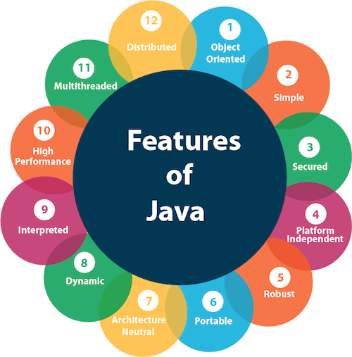

### Simple

Java is very easy to learn, and its syntax is simple, clean and easy to understand. According to Sun, Java language is a simple programming language because: